3D Reference Caliper

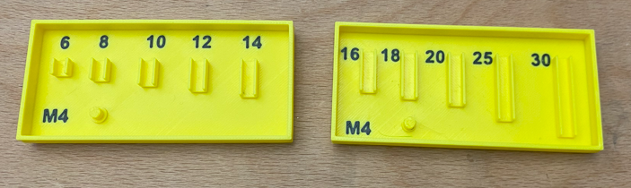

Project Goal
Create a tool to quick sort different screws length.
This should be available for M3 / M4 / M5

M3 Collection
Developing the tool I decided that it is better to split into 3 parts:
- 4, 5, 6, 8, 10
- 12, 14, 16, 18, 20,
- 25, 30

Sketch
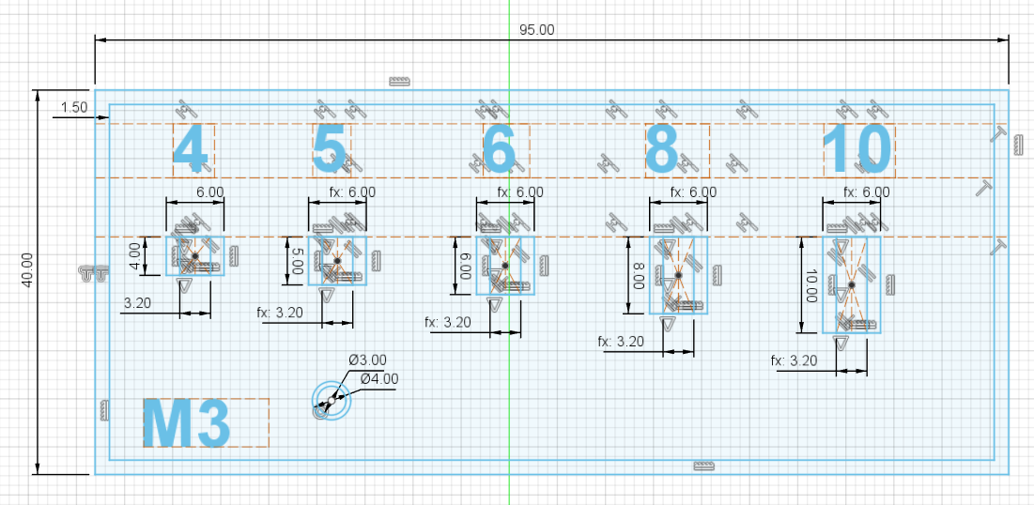

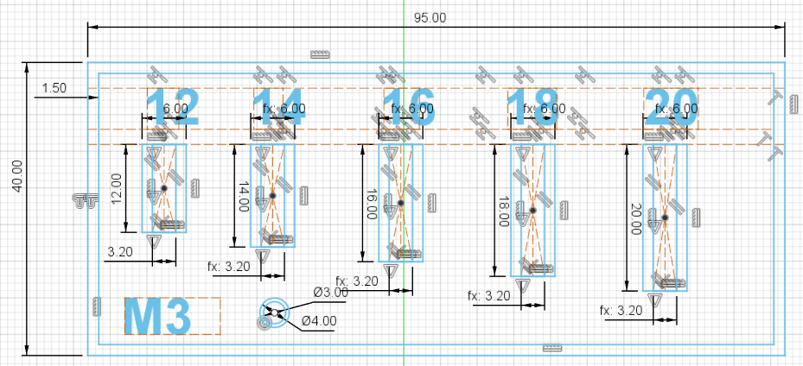

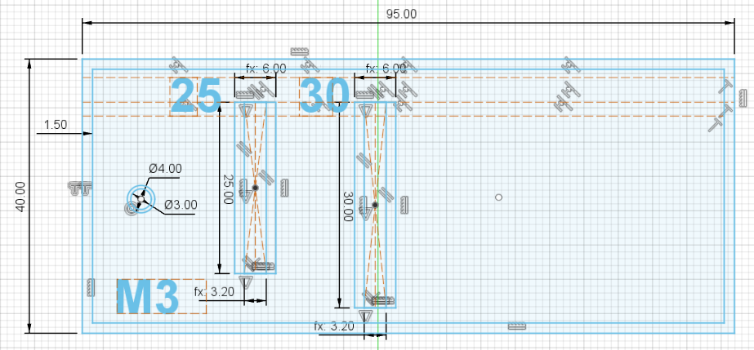

Final Result
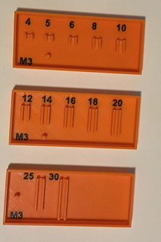

M4 Collection
Developing the tool I decided that it is better to split into 2 parts:
- 6, 8, 10, 12, 14
- 16, 18, 20, 25, 30

Sketch
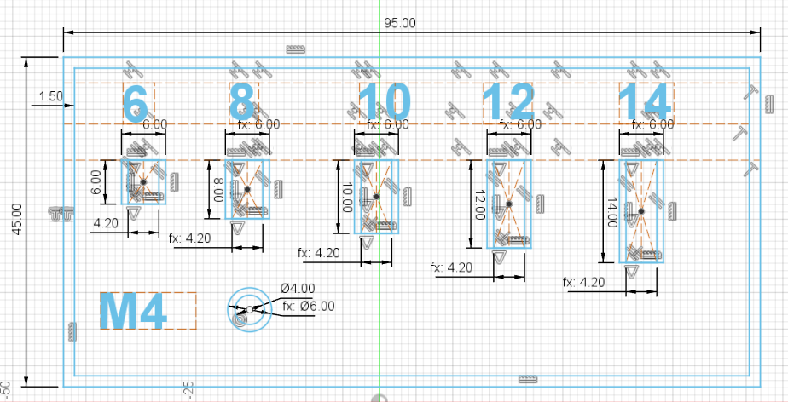

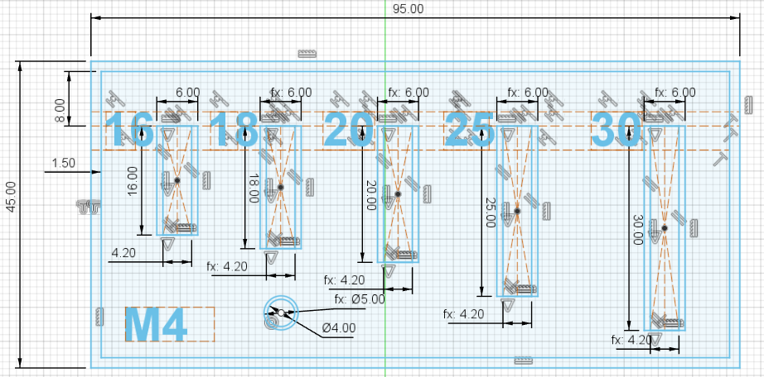

Final Result

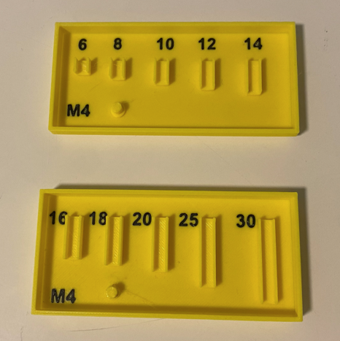

M5 Collection
Developing the tool I decided that it is better to split into 2 parts:
- 6, 8, 10, 12, 16, 18,
- 20, 25, 30, 35, 40

Sketch
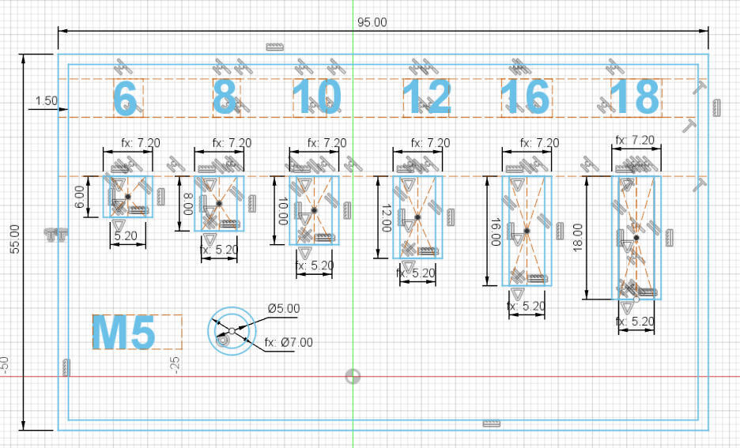

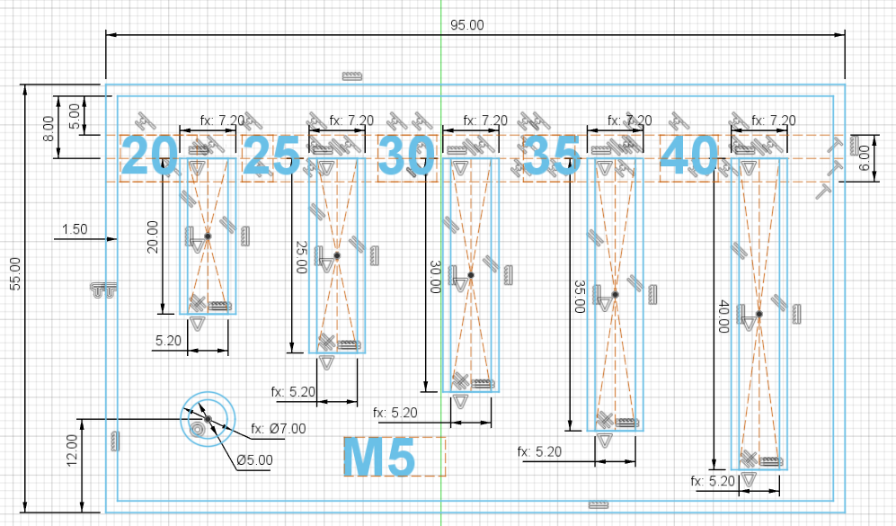

Final result
